**HHC Cancer Institute Geriatric Oncology Rapid Fitness Assessment Workshop**

*An offering for Registered Nurses, Physicians, and APPs interested in performing and integrating the geriatric oncology Rapid Fitness Assessment into their practice.*

**December 13, 2022, 3:30 pm noon – 4:30 pm**

**Presenter**: Rawad Elias, MD, Director of HHC Cancer Institute Geriatric Oncology Program

**Learning Objectives**: As a result of participating in this Live Activity, learners should be able to:

* Define the elements of the Geriatric Oncology Rapid Fitness Assessment
* Demonstrate the RFA Standard work and documentation in Epic
* Interpret RFA results
* List best practice interventions & clinical recommendations based on the RFA results
* Identify common “pitfalls” and work efficiencies when performing the RFA

**Questions:** [**mary.eanniello@hhchealth.org**](mailto:mary.eanniello@hhchealth.org)

**Join Zoom Meeting**

[https://hartfordhealthcare.zoom.us/j/99894328016](https://hartfordhealthcare.zoom.us/j/99894328016" \t "_blank)

Meeting ID: 998 9432 8016

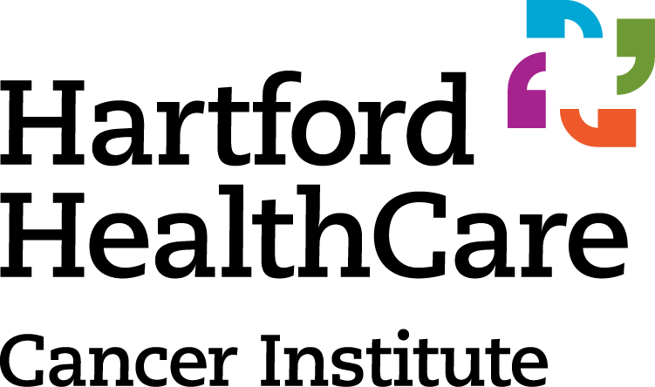

**Psycho-Social**

**Function**

**Medication**

**Nutrition**

**Cognition**

**Comorbidity**